**DR. G.Y PATHRIKAR COLLEGE OF COMPUTER SCIENCE & INFORMATION   
 TECHNOLOGY, MGM UNIVERSITY, CHHATRAPATI SAMBHAJINAGAR**

Mini project

On

**Image Classification and Prediction**

*SUBMITTED BY*

***SAUDAGAR MOHAMMAD SHIBAAN***

***ASUL RATHOD***

*Guided by*

***Dr. Satish Sankaye***

Integrated Bsc-Msc data science Fifth semester,

Academic year 2023-2024

**DR. G.Y PATHRIKAR COLLEGE OF COMPUTER SCIENCE AND INFORMATION**

**TECHNOLOGY, MGM UNIVERSITY, CHHATRAPATI SAMBHAJINAGAR**

**Certificate**

This is to Certify that, SAUDAGAR MOHAMMAD SHIBAAN and ASUL RATHOD has successfully completed the Mini Project on **“Image Classification and Prediction”** for partial fulfillment of the Program Integrated Msc Data Science 5th Semester, of MGM University, Dr. G.Y. Pathrikar College of Computer Science and Information Technology, Chhatrapati sambhajinagar, during the Academic Year 2023-2024.

**Seat no : F0233007**

**Seat no : F0233001**

Dr. Satish Sankaye Dr. Satish Sankaye

**Project Guide Head of the Department**

**Examiner**

|  |  |  |
| --- | --- | --- |
| **Sr No.** | **Contents** | **Page No.** |
|  | Abstract | 1 |
| 1 | Introduction | 1 |
| 2 | Motivation | 2 |
| 3 | Objectives | 2 |
| 4 | Hardware and Software Requirement | 3 |
| 5 | Project | 4-9 |
| 6 | Experiential Result and Result Analysis | 9-13 |
| 7 | Conclusion | 14 |
| 8 | References | 14 |

**Abstract**

Image classification is type of machine learning that involves assigning a label to an image, Label can be categorized like “DOG” and ”CAT” image classification requires the computer vision or understanding as human do. Image classification is an important task because it can solve varity of problems such as image search, object detection, image segmentation, healthcare, automation, agriculture etc.

**Introduction**

Image classification and prediction project is practical application of machine learning and computer vision . it involve training a computer algorithm we have used **Convolutional Neural Network(CNN)** algorithm to analyze and categorize images into predefined class or categories.

In this project, we have Collected 50 images of dogs and 50 images of cats i.e total 100 images are given for training and validation dataset and 20 images new different images are given for testing. using multiple **libraries** loading image . we loaded image we uses cv2 library to check the **dimension** of image it is 3 dimension image and check the **shape** of image by using the ”cv2.imread(“basedata/ /train/CAT/download.jpeg").shape ” and shape is (256, 197, 3) this is shape of ramdom image taken from training dataset and than **rescale** the images by 1/255 of “training and validation dataset, so that all the images will be of same size given in training. (200,200,3) for training and validation dataset, so i.e 200 are pixel height, 200 are pixel width, 3 (RGB color(Red Green Blue) ) .

Training and validation images and then we **categorized** the data into 0 and 1 {0:Cat, 1:Dog} by using code( train_dataset.class_indices ). And than we Defining the model by using Convolutional Neural Network (CNN) and using various activation funtions such as “relu” and “sigmoid”. relu is introduces non-linearity to model and solve vanishing gradient issues and sigmoid predict the probability as an output.

Now, compiling our model and fitting the model. Given the path of test dataset with all different images and model starts predicting the images. and uses confussion matrices i.e(True positive, True negative, False positive(Type-1 error), False negative(Type 2 error).

1

**Motivation**

The field of computer vision offers a numerous opportunities for innovation making it inspiring project to undertake.

making a computer vision understand images and learn different things around the surrounding and solve the problems. This project allows me to give computers the ability to recognize and categorize images, just like our brains do without doubt.

* This project encourages me to how to make computer to learn and classification. It help me to understand the vision of computer by giving different samples of images.
* It motivates me this can be also be usefull in many other field. Such as human image recognition while scanning its face symmetry in order to understand authentic person.
* Medical imaging: Image classification can be used to identify diseases in medical images, such as x-rays, MRI, CT scans this helps the doctors to diagnose diseases  
  more accurately and in less time.
* Object detection and tracking: Image classification can be used to detect and track objects in images and videos. This can be used for applications such as self-driving cars, security systems, and video surveillance.
* Autonomous vahicals: image classification technique can identify objects on the road such as vehicles, humans, animals, traffic signs etc, eg-Tesla, Waymo etc.

**Objectives**

* Develop a model that can accurately classify images into different categories. The model should be able to handle a wide variety of images, including images with different lighting conditions, backgrounds.
* Develop a model that can be used to predict the presence of certain objects or features in images. For example, the model could be used to predict whether or not a person is smiling in a photo, dogs and cat classification.
* Develop the model that can classify and predict the images of different types of cancer cells .
* Develop the model to the environment so that it can classify the images that using CNN algorithm in robotics and machine learning .
* Accuracy must be 90% , given the training up to 80% and rest for testing i.e 20%.

2

**Hardware and software requirement**

**Hardware:**

*Laptop Pavillion 5600H*

|  |  |
| --- | --- |
| Device name | hp-LAPTOP-4G1N80UD |
| Processor | AMD Ryzen 5 5600H with Radeon Graphics 3.30 GHz |
| Installed RAM | 8.00 GB (7.34 GB usable) |
| Device ID | A9161311-2A29-4078-A2CF-7F48C7D9A79F |
| Product ID | 00356-24604-81977-AAOEM |
| System type | 64-bit operating system, x64-based processor |
|  |  |

**Software:**

* Microsoft Word
* Microsoft Edge
* Google
* Youtube
* Jupyter notebook and anaconda installed
* Windows operating system

3

**PROJECT**

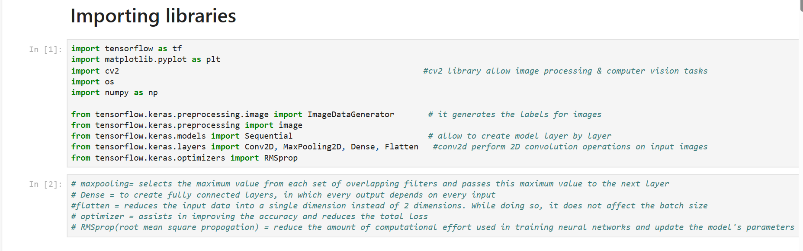

* **tensorflow** library performs mathematical computation. tensor is multidimensional array. And flow is defines flow of data operation we uses tensorflow in layers.
* **cv2** library it perfroms image processing and filtering for computer vision tasks.
* **os** library interact with operating system, it navigate with file system,works with directories we uses os in testing path in our project.
* **from tensorflow.keras.preprocessing.image import** **ImageDataGenerator** is a tool in Keras for augmenting and preparing images for training deep learning models.
* **from tensorflow.keras.models import sequential** it allow to create model layer by layer.
* **maxpooling**= selects the maximum value from each set of overlapping filters and passes this maximum value to the next layer.
* **Dense** = to create fully connected layers, in which every output depends on every input.
* **flatten** = reduces the input data into a single dimension instead of 2 dimensions. While doing so, it does not affect the batch size.
* **optimizer** = assists in improving the accuracy and reduces the total loss.
* **RMSprop**(root mean square propogation) = reduce the amount of computational effort used in training neural networks and update the model's parameters during training.

4

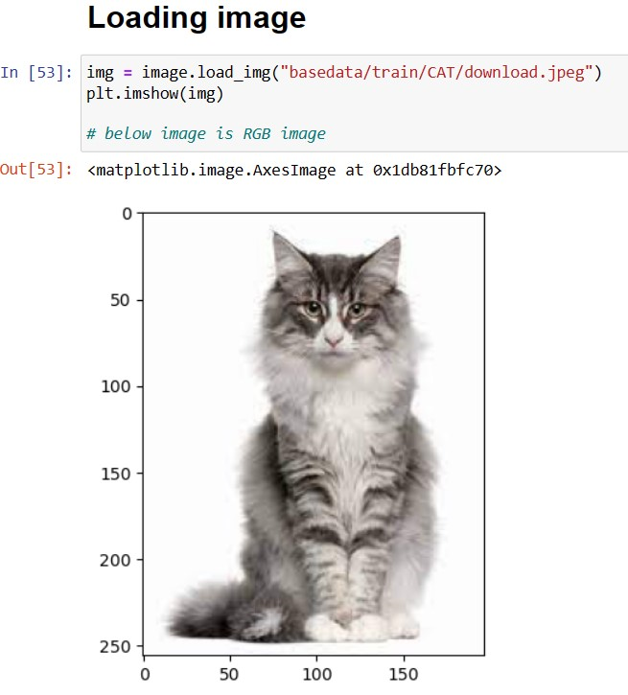

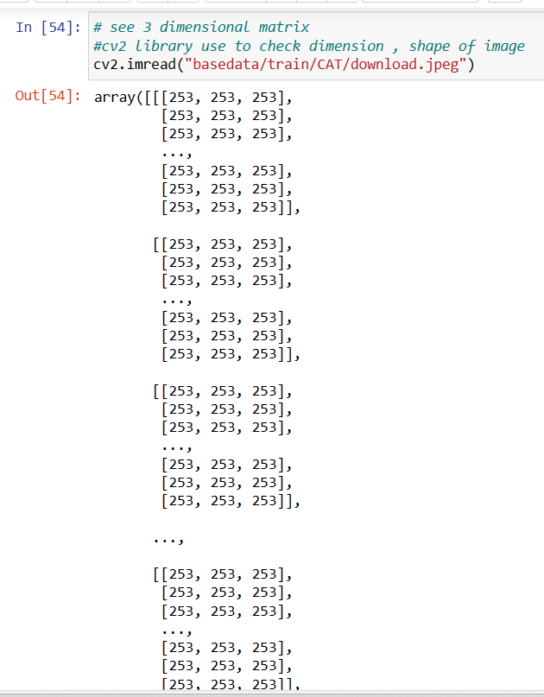 5

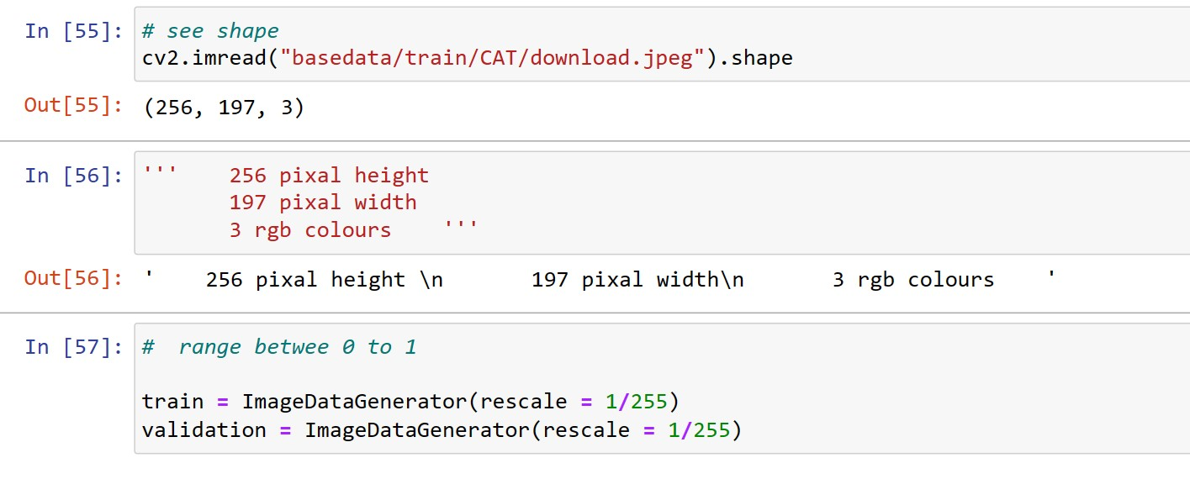

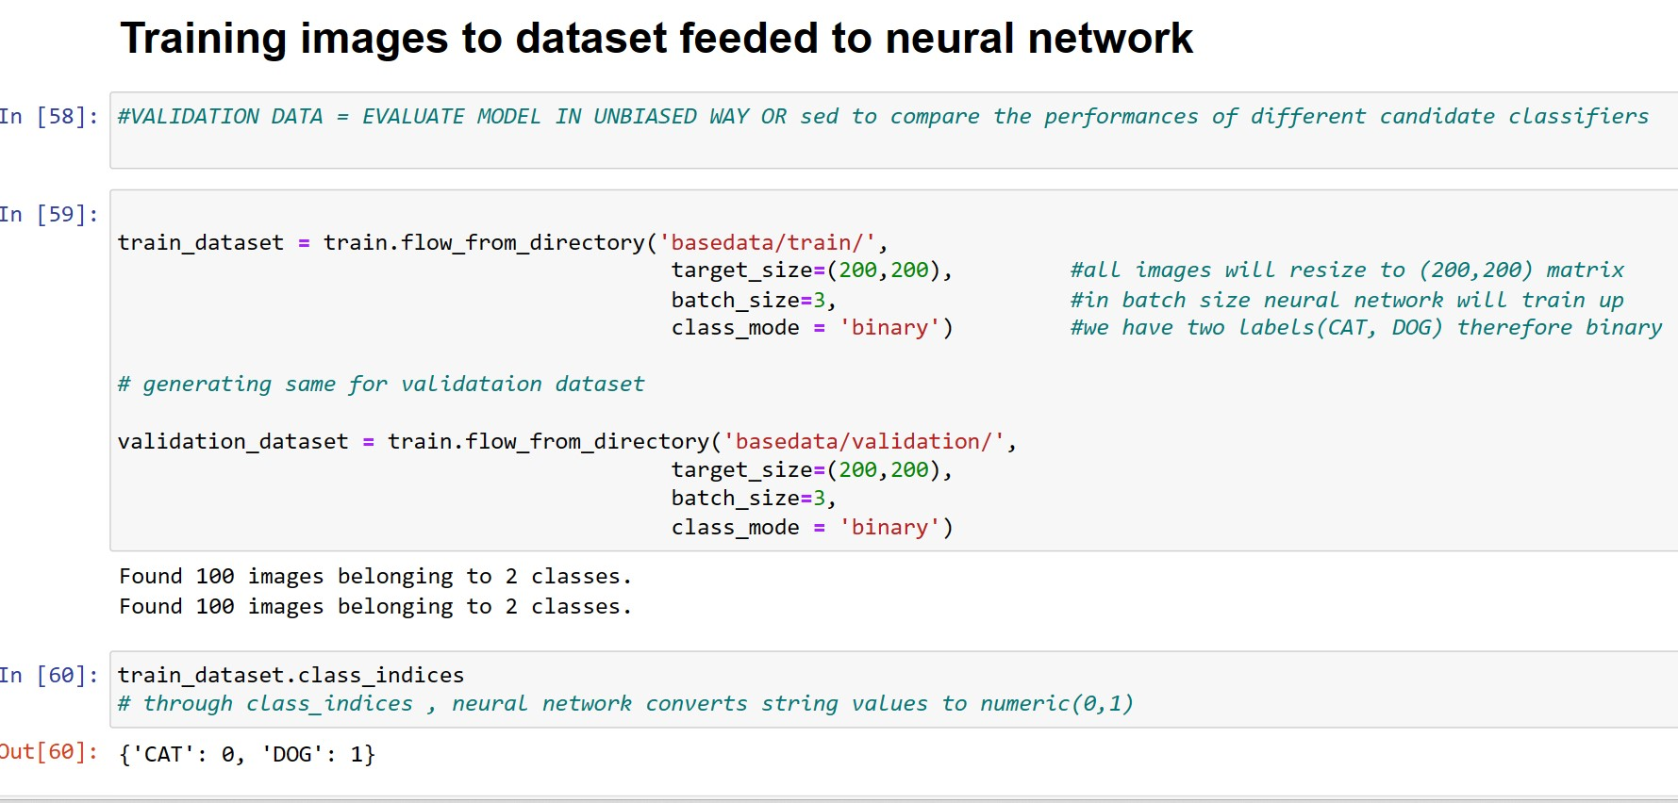

6

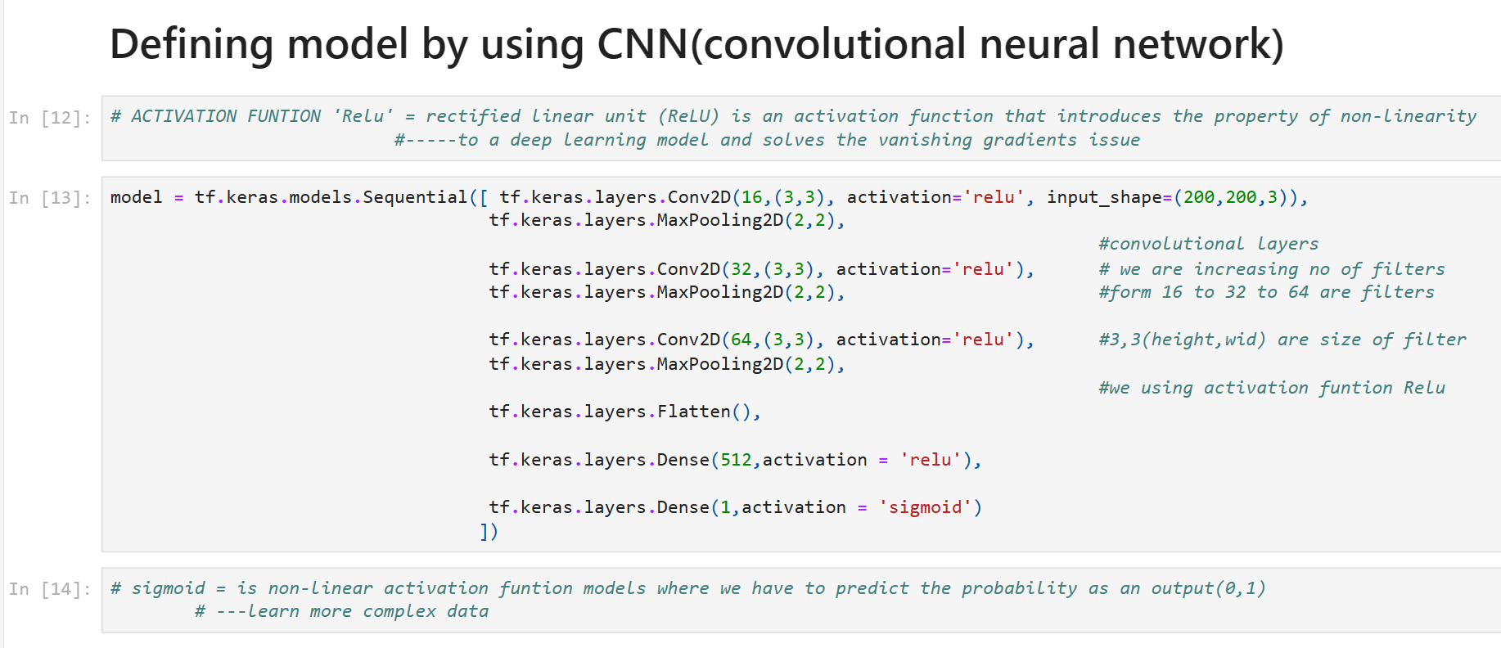

ReLU prevents the computation required to run the neural network from growing exponentially.

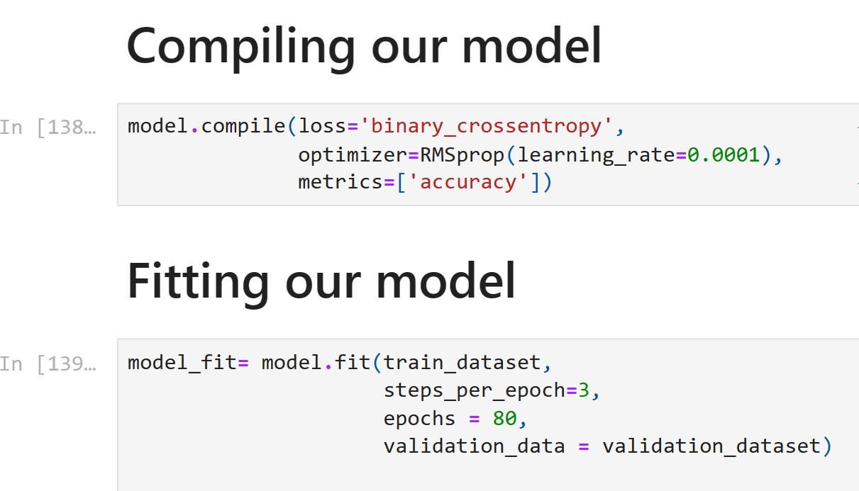

binary_crossentropy=cross-entropy loss between true labels and predicted labels.  
RMSprop is an optimizer.  
optimizing on matrix.

STEPS_PER_EPOCH = total number of steps taken before one epoch is finished and the next epoch starts during training. It is typically set to the total number of samples in your dataset divided by the batch size.

#epochs = Each time passing of training dataset,through algo to complete an epoch.  
  
  
 7

*out:* 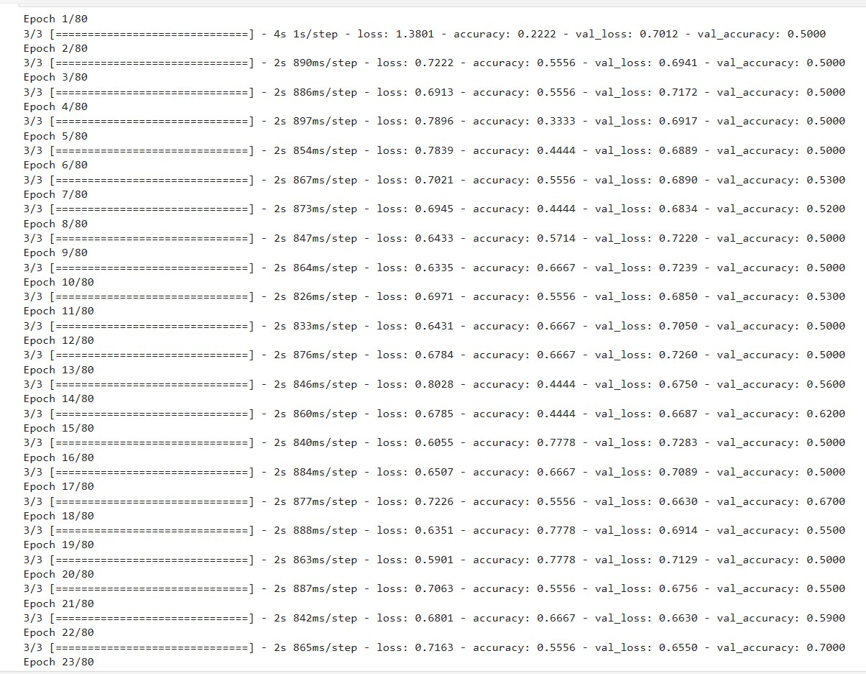

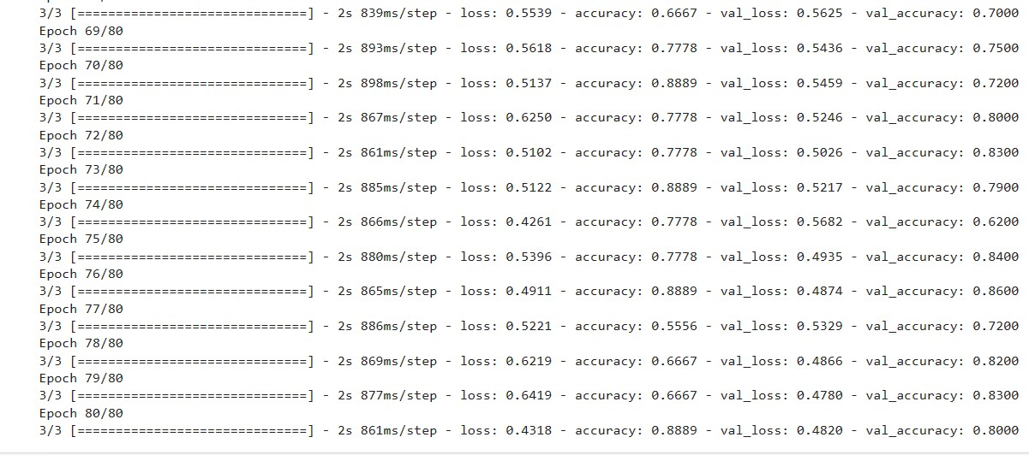

8

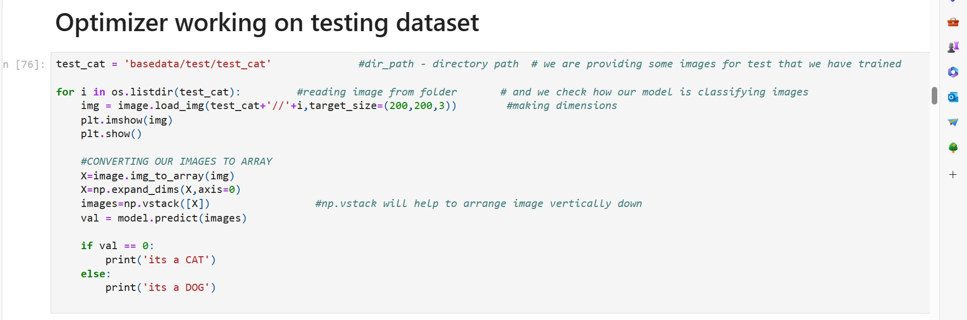

**Experimental result and result analysis**

**Cats**

Out:

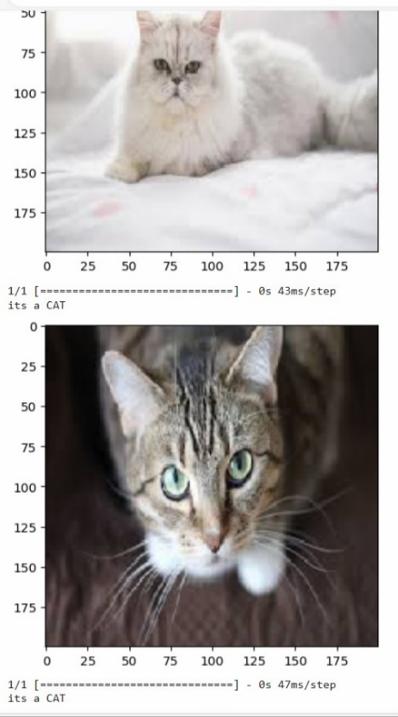

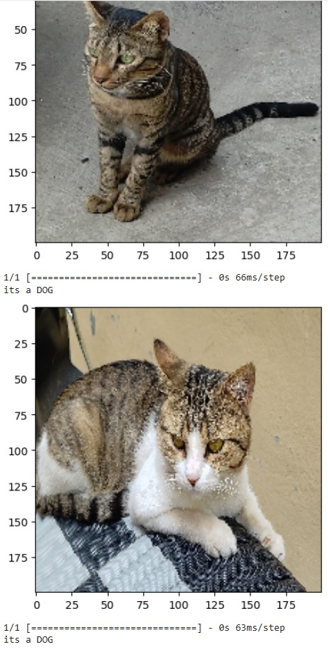 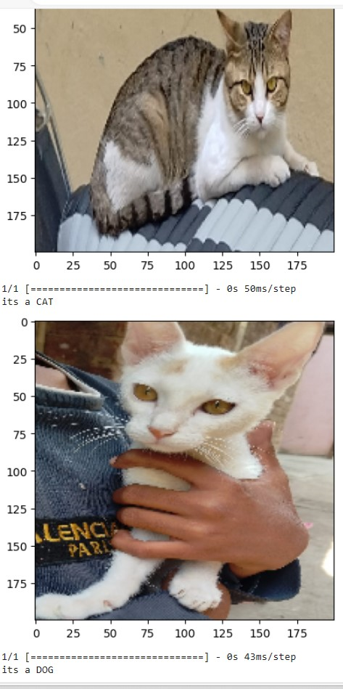

9

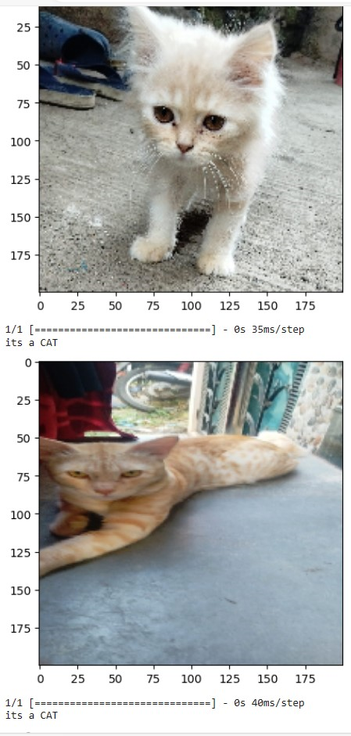 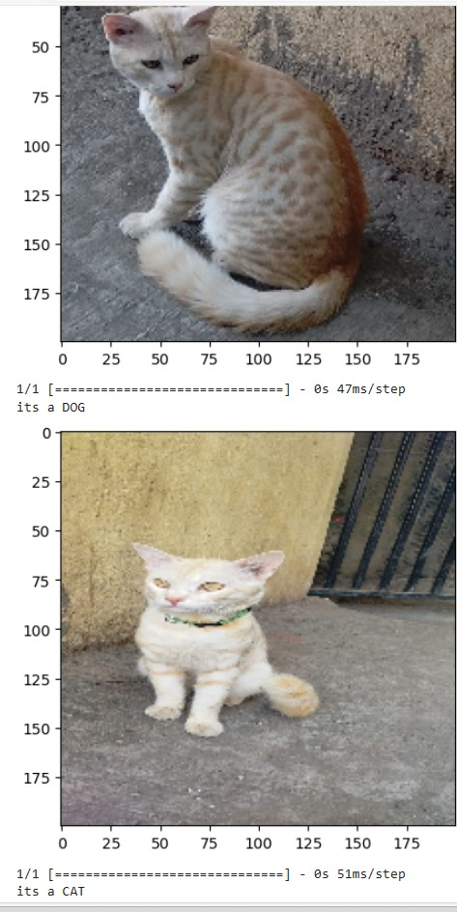

10

**Dogs**

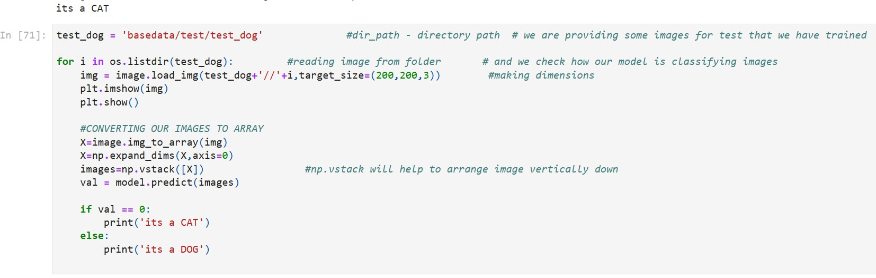

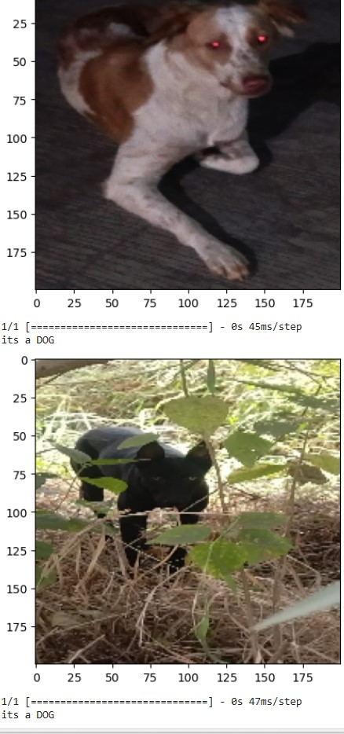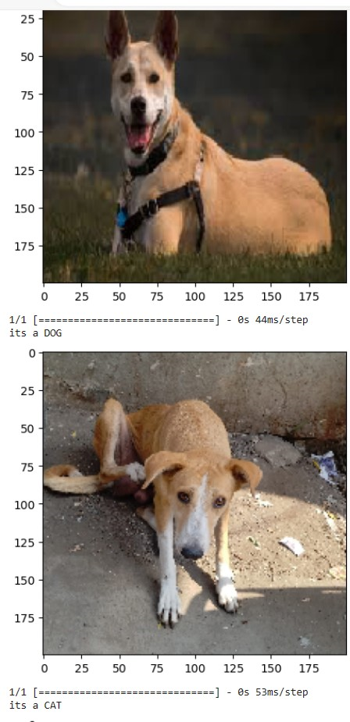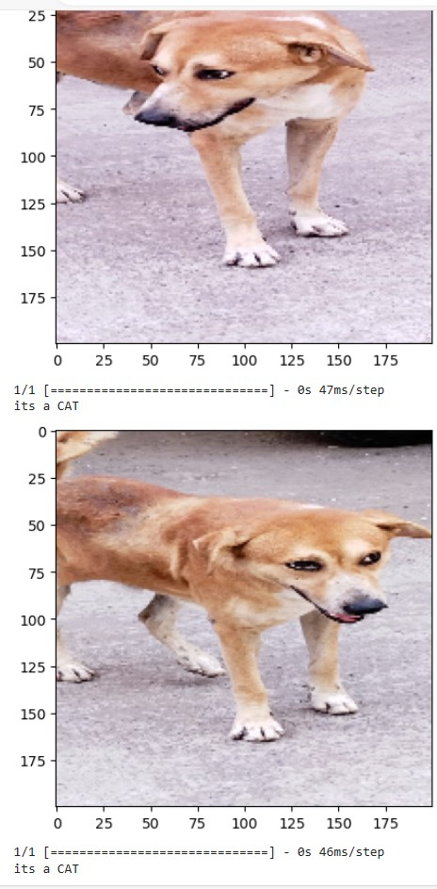  
  
  
  
  
 11

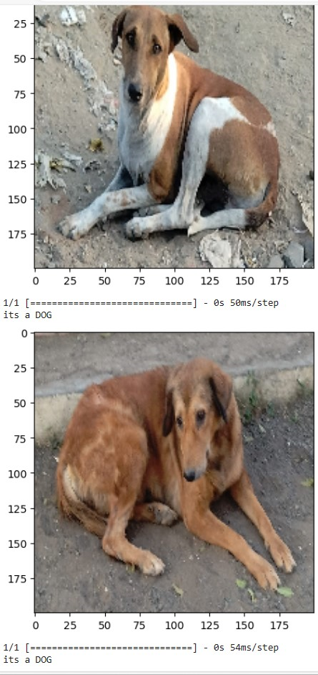 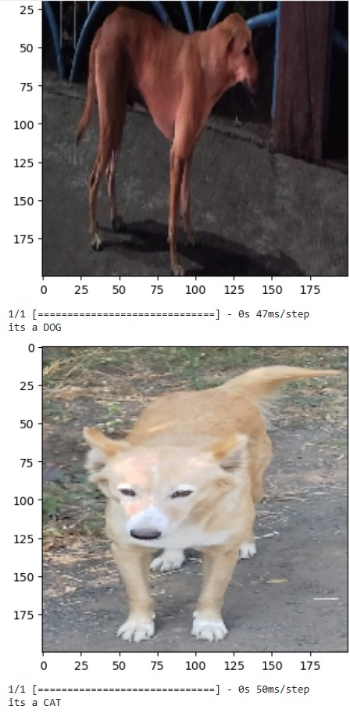

12

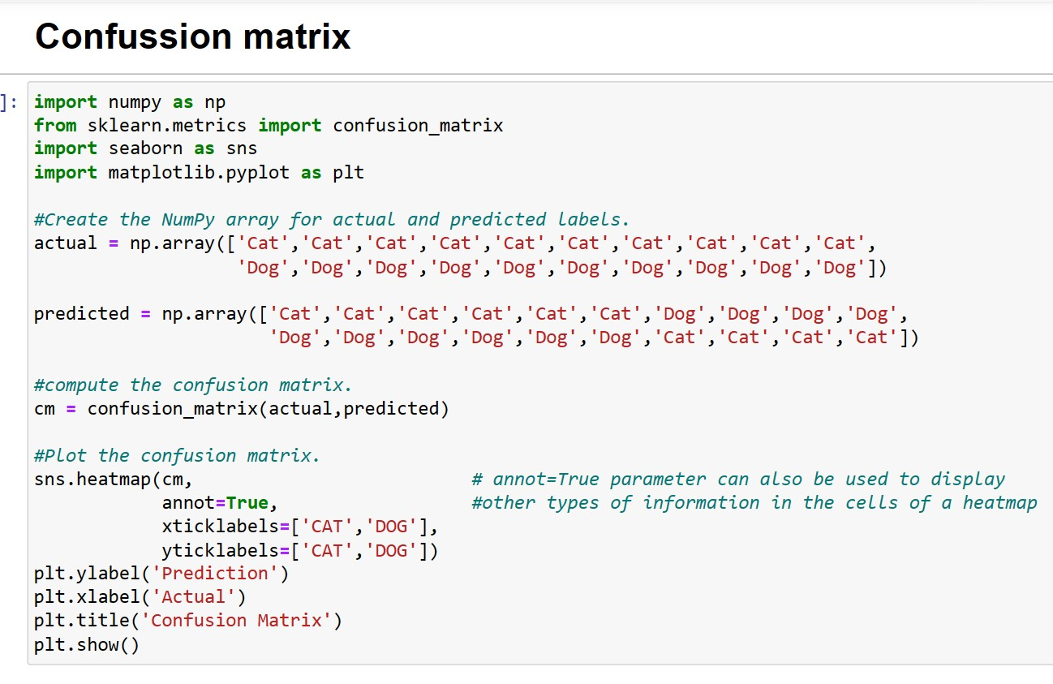

OUT:

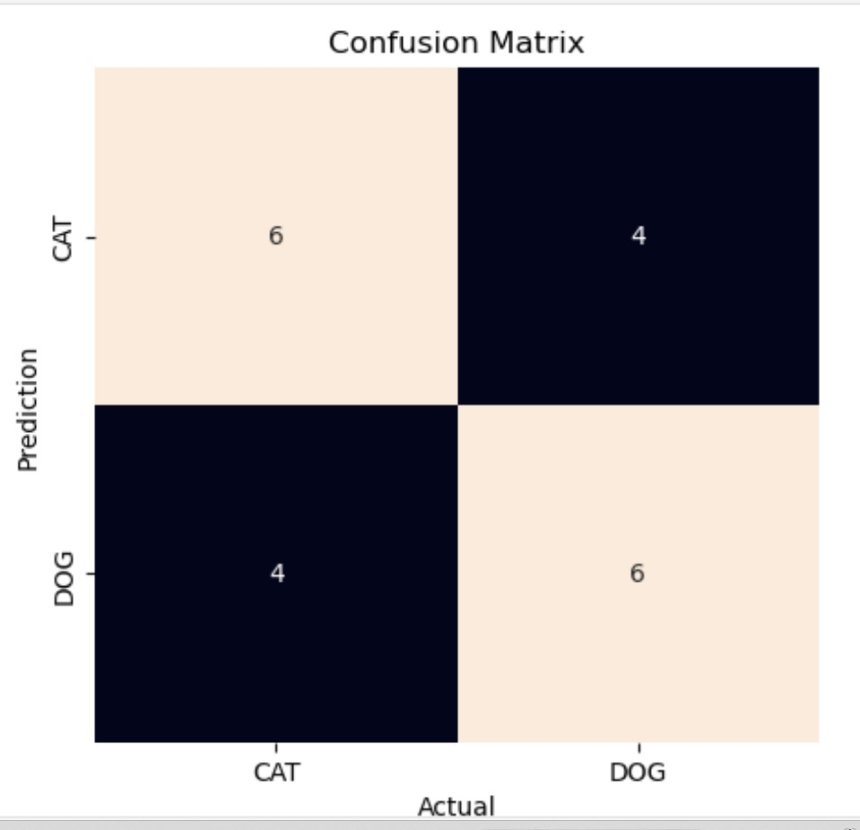

TRUE POSITIVE means Actually it is DOG and our model’s prediction it is DOG.  
FALSE POSITIVE means Actually it is DOG but our model’s prediction is cat.   
TRUE NAGATIVE means Actually it is CAT and our model’s prediction is CAT.  
FALSE NAGATIVE means Actually it is CAT but our model’s prediction is dog.

13

**Conclusion**

In this project, we have developed an image prediction system that can classify images into different categories. The system uses a pre-trained convolutional neural network (CNN) model that has been trained on a large dataset of images. The model is able to classify images with high accuracy, and it can be used to identify a variety of objects, scenes, and activities.

We have evaluated the system on a variety of images, and we have found that it is able to perform well on a variety of tasks. For example, the system is able to correctly identify objects in images, such as cars, dogs, and people.

Example- the system could be used to help people with visual and identify objects and scenes in the world around them. It could also be used to automate tasks such as image classification and object detection and security surveillance.

**Reference**

* Github link
* Youtube videos
* https://www.youtube.com/watch?v=uqomO_BZ44g&t=1s&ab_channel=WhenMathsMeetCoding

14